Ana Beatriz de Sousa Costa - 01191000

**CONTINUADA 2 – 23/04/2019**

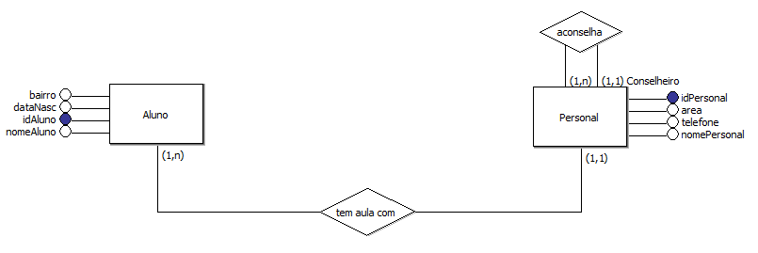

create database Personal;

use Personal;

create table T_Personal (

idPersonal int primary key auto_increment,

nomePersonal varchar(40),

area varchar(40),

telefone char(10),

fkConselheiro int

)auto_increment= 1;

alter table T_Personal add foreign key (fkconselheiro) references T_Personal(idPersonal);

desc t_personal;

insert into T_Personal (idPersonal, nomePersonal, area, telefone) values

(null, 'Paulo', 'Musculação', '95436-0953'),

(null, 'Bruno', 'Pilates', '94325-7628'),

(null, 'Fernanda', 'Boxe', '92134-7659'),

(null, 'Chris', 'Yoga', '93210-3425');

update t_personal set fkConselheiro = 3 where idPersonal in (1,4);

create table aluno (

idAluno int primary key auto_increment,

nomeAluno varchar(40),

bairro varchar(40),

dataNasc date,

fkPersonal int,

foreign key (fkPersonal) references t_personal(idPersonal)

)auto_increment=1000;

insert into aluno values

(null, 'Bianca', 'Lagoa Bonita', '2000-02-18', 2),

(null, 'José', 'Bairro B', '1998-03-20', 4),

(null, 'Luis', 'Capão Redondo', '1994-01-30', 1),

(null, 'Geovanna', 'Bairro C', '2001-09-20', 3),

(null, 'Marcos', 'Jadim Belo', '1999-04-25', 4),

(null, 'Jennifer', 'Interlagos', '2001-05-14', 2);

select * from t_personal;

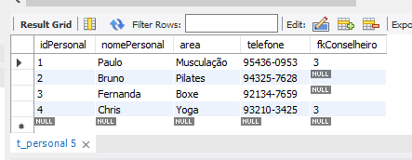

select * from aluno;

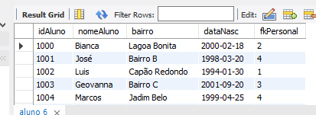

select p.*, idAluno, nomeAluno, bairro, datanasc from t_personal as p, aluno where fkpersonal = idpersonal;

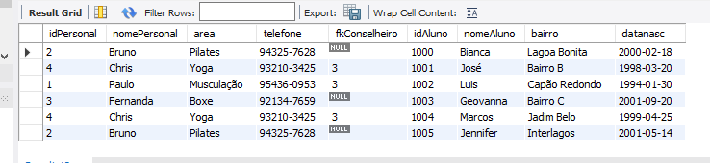

select p.*, idAluno, nomeAluno, bairro, datanasc from t_personal as p, aluno where fkpersonal = idpersonal and nomePersonal = 'chris';

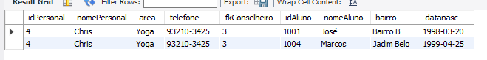

select p.*, c.* from t_personal as p, t_personal as c where p.fkconselheiro = c.idPersonal;

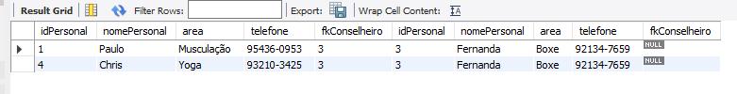

select p.*, c.* from t_personal as p, t_personal as c where p.fkconselheiro = c.idPersonal and p.nomePersonal = 'paulo';



select p.*, idAluno, nomeAluno, bairro, datanasc, c.idpersonal, c.nomepersonal, c.area, c.telefone from aluno as a, t_personal as p, t_personal as c where a.fkpersonal = p.idpersonal and p.fkconselheiro = c.idpersonal;

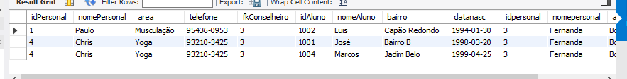

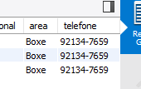

select p.*, idAluno, nomeAluno, bairro, datanasc, c.idpersonal, c.nomepersonal, c.area, c.telefone from aluno as a, t_personal as p, t_personal as c where a.fkpersonal = p.idpersonal and p.fkconselheiro = c.idpersonal and p.nomePersonal = 'Chris';

